2019 SAPFC PHOTO ORDER FORM
PLAYERS NAME: ______________________________________________________
TEAM: _________________________________________________________________
CONTACT NAME: _____________________________________________________
PHONE: _______________________________________________________________
EMAIL: ________________________________________________________________

- $25 8” x 12” Individual plus team photo
- $40 8” x 12” Individual plus team photo + extra 8” x 12” Individual
- $25 8” x 12” Individual
- $25 8” x 12” Team
- $25 8” x 12” Sibling

Payment by cash on the night of photo sitting otherwise via bank transfer
Account: SA Panthers FC
BSB: 633-000
Account No: 151695350
Reference: Team/Surname i.e. 14/Smith

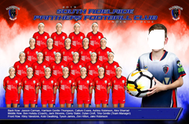
Sample only of Individual plus team photo

